Weighing The Three Bears

The Three Bears weigh themselves on the bathroom scales. Mummy Bear holds Little Bear in her arms.

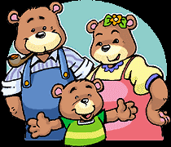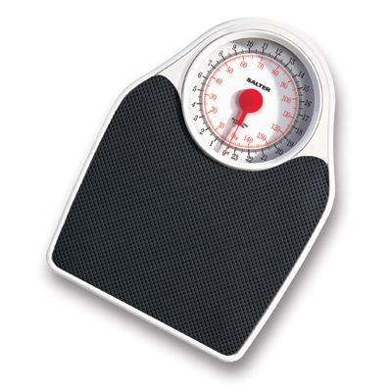

Mummy Bear and Little Bear together weigh 83 kg.
Mummy Bear by herself weighs 62 kg.
Daddy Bear weighs 4 times as much as Little Bear.

What does Little Bear weigh?

What does Daddy Bear weigh?

How much heavier than Mummy Bear is Daddy Bear?

How much do the three bears weigh altogether?

